# National University of Computer and Emerging Sciences logo.pngICT- Lab

**LAB# 01**

**Assignment**

*Submitted By*

Humna Khan

(22P-9016)

*Submitted to*

Mr. M. Ahsan

(INSTRUCTOR CS)

**DEPARTMENT OF COMPUTER SCIENCE**

**FAST NATIONAL UNIVERSITY OF COMPUTER AND EMERGING SCINCES, PESHAWAR**

Session 2022-2026

## TASK 1

https://www.linkedin.com/in/humna-khan-979503226/

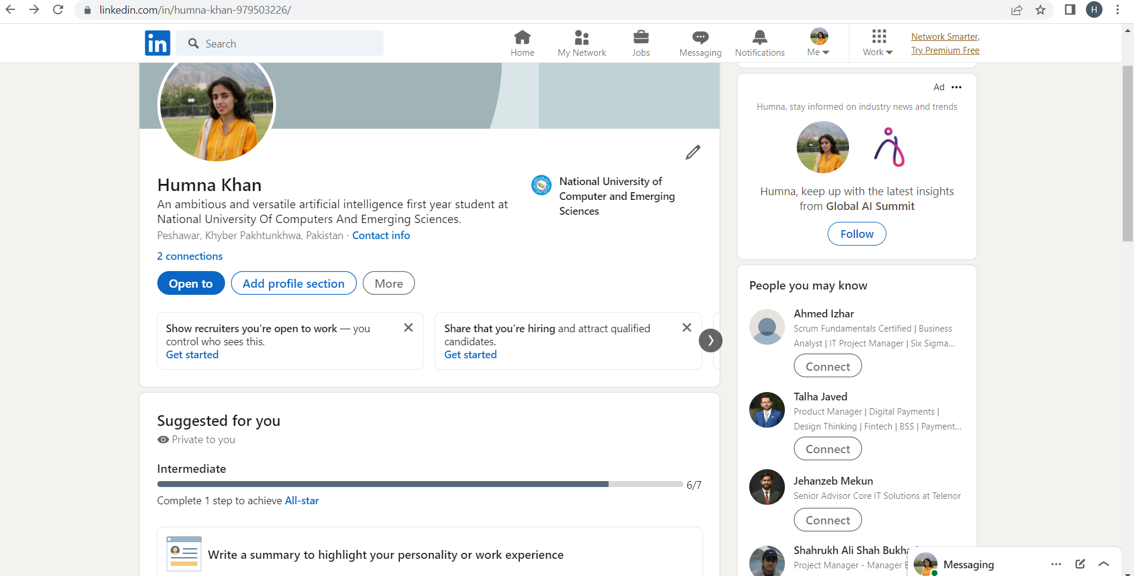

## Task 2

https://github.com/Humna-Khan/Humna-Khan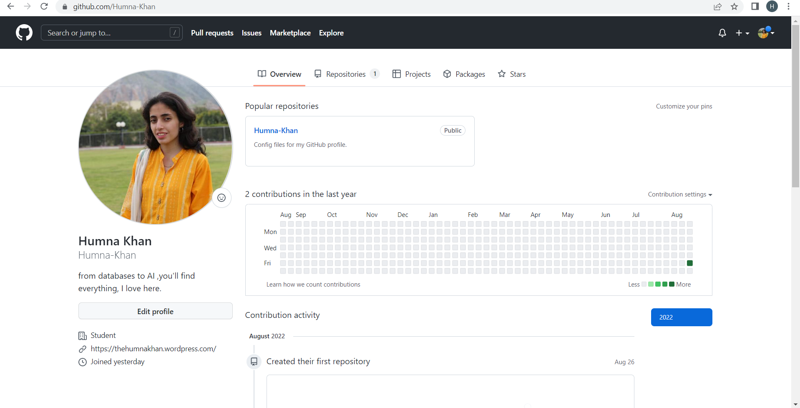

## TASK 3

https://thehumnakhan.wordpress.com/

